|  |
| --- |
| **Discrete Structures (CS1005)** |
| **Course Instructor(s):** |
| Ms.Shafaq Riaz Bhatti  **Section(s): (SE A,B,C)** |

|  |  |
| --- | --- |
| **Sessional-II Exam** | |
| **Total Time (Hrs):** | **1** |
| **Total Marks:** | **40** |
| **Total Questions:**  **Date:** Apr 8, 2025 | **5** |

**___________ ___________ _____________________**

**Roll No Course Section Student Signature**

**Do not write below this line.**

**Attempt all the questions.**

**Q1: [Analyze and apply logical reasoning in problem-solving] [20 Marks]**a) Determine whether the statements in (a) and (b) are logically equivalent. **[2]**

* 1. Basit is both a batsman and wicket keeper and Amin in a batsman, but Amin is not both batsman and wicket keeper.
  2. It is not the case that both Basit and Amin are both batsman and wicketkeeper, but it is the case that Amin is a batsman and Basit is both a batsman and wicketkeeper.   
       
       
       
     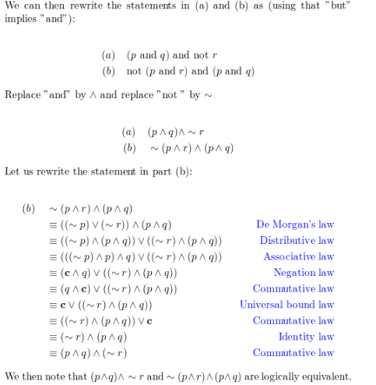

**b)** Let *D* = *E* = {22, 21, 0, 1, 2}. Write negations for each of the following statements and determine which is true, the given statement or its negation. **[2]**

* 1. ∀*x* in *D*, ∃*y* in *E* such that *xy* ≥ *y*.
  2. ∃*x* in *D* such that ∀*y* in *E*, *x* ≤ *y*.   
       
       
     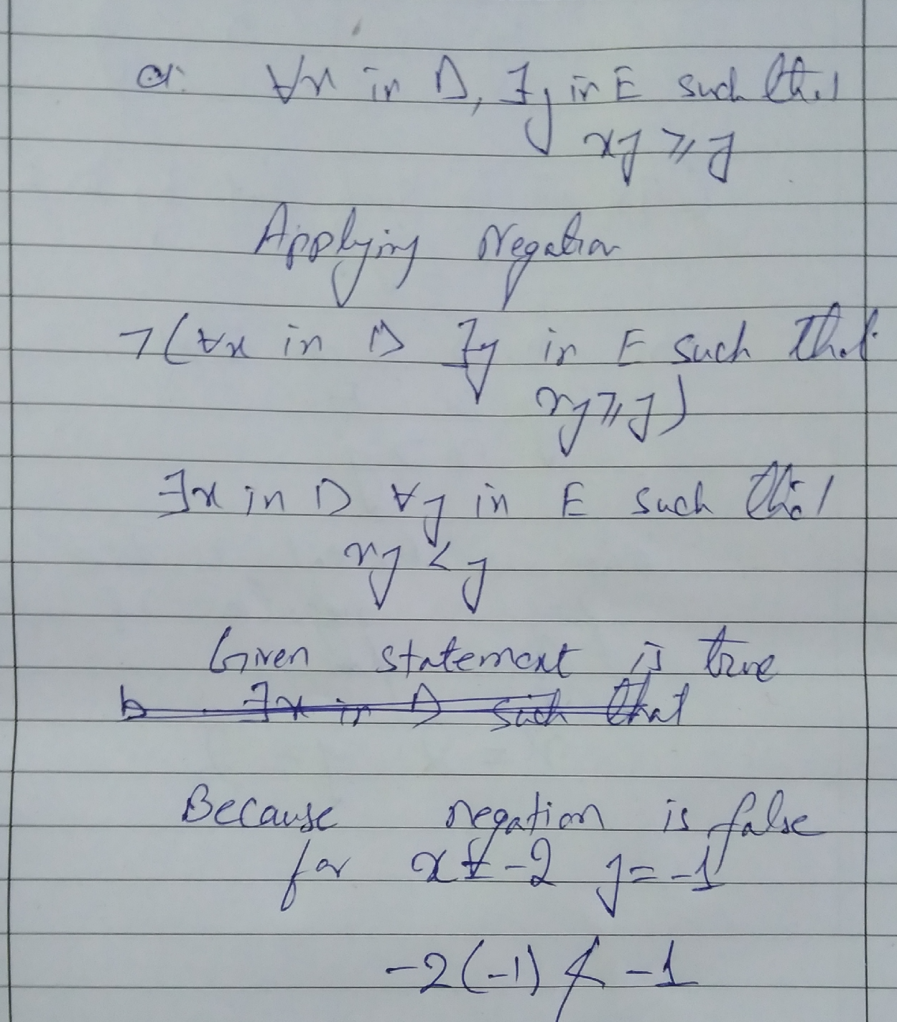  
       
     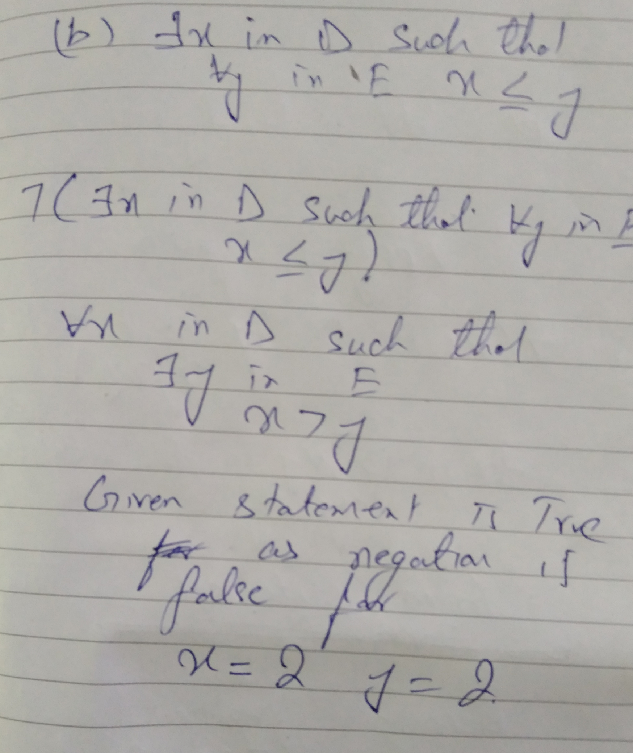

**c)** Define **[2]**

$$A = \left\{ x∈N,x≤10\right\} and B = \{y|y∈N, y≤15; y is even\}$$

Recall that $U-V=\{u|u∈U and u∉V\}$

Write a predicate of which $A-B$ are the truth sets. $$P\left(x\right):x∈N∧x≤10∧x is odd$$

ii) Write a predicate of which $B-A$ are the truth sets.

$$P\left(x\right):x∈N∧12≤x≤15∧x is even$$

d) Let $D_{x}$ and $D_{y}$ denote the domains of $x$ and $y$, respectively. Consider the following quantified statement

$∀x ∃y [x + y = 17]$**[3]**

Determine the truth value of the quantified predicate in different domains.

1. $D_{x}=D_{y}=$ the set of integers. True
2. $D_{x}=D_{y}=$ the set of positive integers. False
3. $D_{x}=$ the set of integers and $D_{y}$ = the set of positive integers. False

e) January 1, 2000 was a Saturday, and 2000 was a leap year. What day of the week will January 1, 2050, be?  
  
  
  
 **[2]**  
f) 0.56565656 is rational number? if yes then write it in rational number form  
  
  
  
 **[2]**  
g) Assume that k is a particular integer. Is 2k − 1 odd?  
  
  
  
 **[2]**  
h) What rule of inference is used in each of these arguments? **[3]**

Alice is a mathematics major. Therefore, Alice is either a mathematics major or a computer science major.  
  
**Conjunction/**

Jerry is a mathematics major and a computer science major. Therefore, Jerry is a mathematics major.  
  
**Simplification**

If it is rainy, then the pool will be closed. It is rainy. Therefore, the pool is closed.  
  
**Modus Ponen**

1. Find a counter example, if possible, to these universally quantified statements, where the domain for all variables consists of all integers. **[2]**
2. ∀x∀y(x 2 = y 2 → x = y).
3. ∀x∃y(y 2 = x).

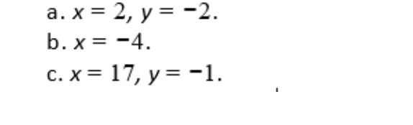

**Question 2 :[CLO: Implement and analyze logic programming concepts and formal logic representations] [10 marks]**  
  
 a) Given the knowledge base of Prolog given below, study the queries underneath it. Indicate whether you think a particular query will succeed or fail by answer yes or no **[4]**

likes(john,mary).

likes(john,trains).

likes(peter,fast_cars).

likes(Person1,Person2):-

hobby(Person1,Hobby),

hobby(Person2,Hobby).

hobby(john,trainspotting).

hobby(tim,sailing).

hobby(helen,trainspotting).

hobby(simon,sailing).

1) ?- likes(john,trains). ______________yes______________

2) ?- likes(helen,john). _________________yes______________

3) ?- likes(tim,helen). _____________________no___________

4) ?- likes(john,helen)._______________________yes_________

b) **Express each of these system specifications using predicates, quantifiers, and logical connectives, if necessary. [6]**

a. At least one console must be accessible during every fault condition.  
b. The e-mail address of every user can be retrieved whenever the archive contains at least one message sent by every user on the system.  
c. For every security breach there is at least one mechanism that can detect that breach if and only if there is a process that has not been compromised.  
d. There are at least two paths connecting every two distinct endpoints on the network.  
e. No one knows the password of every user on the system except for the system administrator, who knows all passwords. **|  
  
  
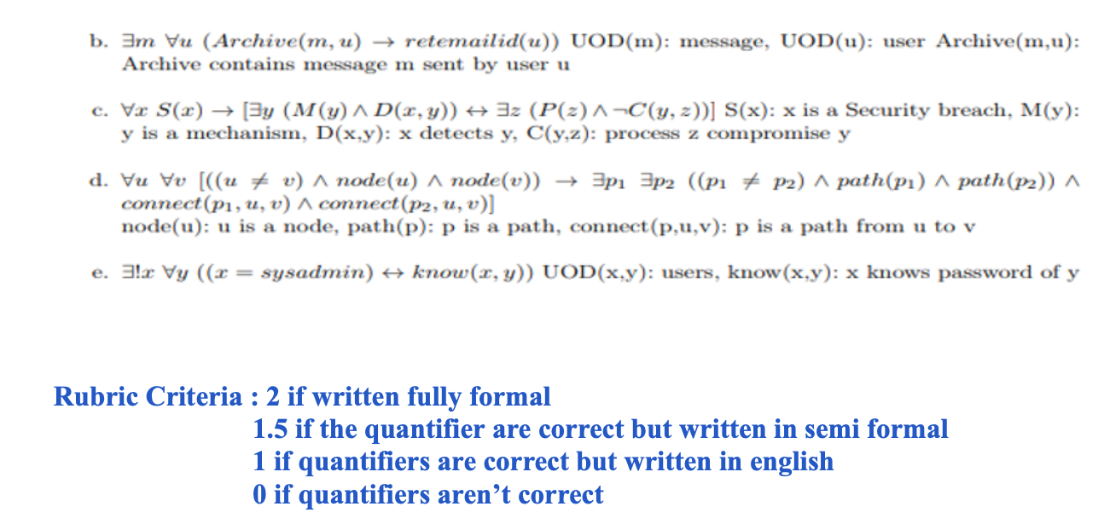**

**Question 3 [CLO 2: Apply algorithmic and mathematical proof techniques to discrete problems] [10 marks]**

**a)** Prove the following statement directly from the definitions of even and odd: For all

integers a, if a is even, then 5(a + 3) is odd. 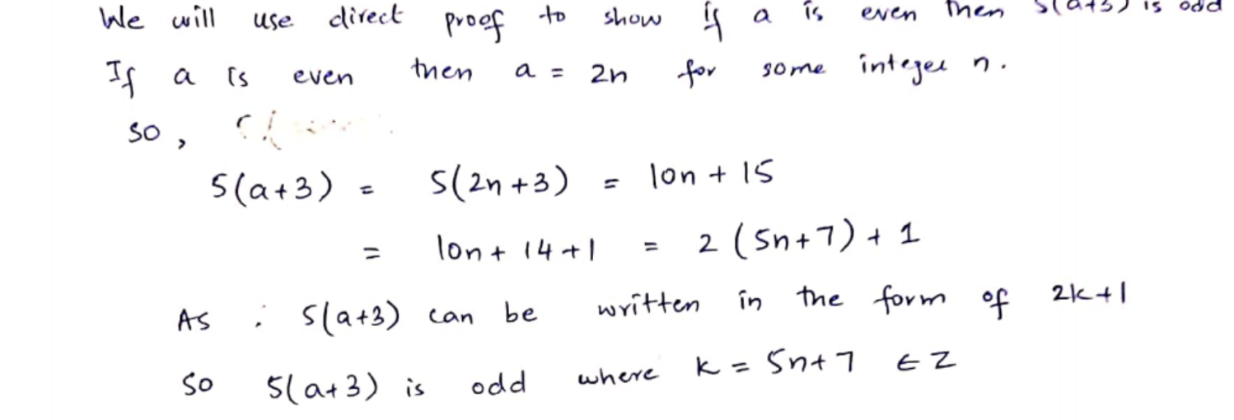  **[5]**

**b)** Aladdin finds two trunks A and B in a cave. He knows that each of them either contains a treasure or a fatal trap. **[5]**

On trunk A is written: “At least one of these two trunks contains a treasure.”

On trunk B is written: “ In A there’s a fatal trap.”

Aladdin knows that both the inscriptions are true. Can Aladdin choose a trunk being sure that he will find a treasure? If this is the case, which trunk should he open?

